Dry deposition of reactive nitrogen from satellite observations of ammonia and nitrogen dioxide over North America

S. K. Kharol1*, M. W. Shephard1, C. A. McLinden1, L. Zhang1, C. E. Sioris1, J. O’Brien1, R. Vet1, K. E. Cady-Pereira2, Jacob Siemons1,3, and N. A. Krotkov4

1 Environment and Climate Change Canada, Toronto, Ontario M3H 5T4, Canada.

2Atmospheric and Environmental Research, Inc., Lexington, MA, USA.

3University of Waterloo, Waterloo, ON, Canada

4Atmospheric Chemistry and Dynamics Laboratory, NASA Goddard Space Flight Center, Greenbelt, Maryland, USA

Corresponding author: Shailesh Kumar Kharol ([shailesh.kharol@canada.ca; shaileshan2000@gmail.com)](mailto:shailesh.kharol@canada.ca;%20shaileshan2000@gmail.com))

Key Points:

* First use of satellite observations to estimate the dry deposition of Nr from NH3.
* Satellite estimates of Nr (NH3+NO2) dry deposition indicates that the NH3 contribution dominates over most geopolitical regions across the North America.
* Forest fires are major contributor of Nr dry deposition from ammonia in northern Canada where there is negligible contribution from agriculture activities.

Abstract

Reactive nitrogen (Nr) is an essential nutrient to plants and a limiting element for growth in many ecosystems, but has deleterious effects on ecosystems in its access. Here we used satellite observations of surface concentration, together with a dry deposition scheme, to estimate the reactive nitrogen (Nr) dry deposition from both short-lived NH3 and NO2 nitrogen species over North America during the warm season. These maps provide an observation-based integrated view of deposition across much of the continent showing regions of background and enhanced deposition, and the relative importance of these species to the Nr budget. These satellite estimates demonstrate that the NH3 contribution dominates over NO2 for most regions (~80% in Canada, and ~65% in US), with some regional exceptions (e.g. Alberta, New Jersey, Connecticut, Massachusetts). The US has ~70% greater dry deposition of total reactive nitrogen from NO2 and NH3 than Canada during this period. Forest fires are also shown to be the major contributors of NH3 dry deposition in northern latitudes during the warm season, and can often deposit 2-3 times more Nr than from expected background amounts without fires.

1. Introduction

Nitrogen is an essential element for flora, fauna and human’s life existence on earth and is not usable in its chemically unreactive form (N2) by most of organisms and plants [*Erisman et al.*, 2011]. In order to be used by animals and plants it needs to go through its nitrogen fixation into its biologically functional form commonly known as “reactive nitrogen” (Nr). Reactive nitrogen is produced naturally through biological nitrogen fixation (i.e. legumes, blue-green algae, etc.), and by lightning. There is also human-induced nitrogen fixation (i.e. Haber-Bosch industrial production of ammonia), which presently exceeded the natural fixation [*Fowler et al.,* 2013], and can dramatically altered the global nitrogen cycle [*Erisman et al*., 2015]. Deposition of Nr into the ecosystem provides important nutrients, but in excess deposition can cause various deleterious effects on environment leading to ecosystem impacts such to soil acidification [*Galloway et al.*, 2013], eutrophication [*Bergstrom et al*., 2006], vegetation type changes, and biodiversity loss [*Fenn et al.,* 2010; *Bowman et al*., 2012; *Sheppard et al*. 2011; *Bauer et al*., 2016]. On the other hand, deficiency of Nr for agricultural lands can lead to decrease crop production, which can reduce the world food supply. ...[ref]

Nr includes all active nitrogen compounds in the ecosystem (i.e. ammonia (NH3) and ammonium (NH4+), nitrogen dioxide (NO2), nitric oxide (NO), nitric acid (HNO3), and nitrate (NO3-), nitrous oxide (N2O), and organic compounds (i.e. urea).Nr is mainly released into the atmosphere as NH3, NOx (NO+NO2), and N2O. NH3, NOx and HNO3 (secondary atmospheric production) are considered the most common atmospheric gaseous components of the dry deposition of Nr [*Hertel et al.*, 2012]. The relative contribution of the atmospheric emissions varies from location-to-location, but NH3 + NOx make up approximately 90% of the total reactive nitrogen emitted into the atmosphere, with NO2 being approximate 70-80% of NOx [Provide some example references here from Jason’s work and literature]. Here we are focusing on satellite observations of highly variable atmospheric ammonia (NH3) and nitrogen dioxide (NO2), which are a major component of the reactive nitrogen (Nr) budgets and have large uncertainties in global emissions [ref]. In this study we are disregarding N2O, which is mainly important in the stratosphere and has reduced variability in the troposphere so it can be monitored more effectively by more sparse ground-based observations. We are also not measuring directly the dry deposition of NO, which has a contribution ~20-30% of NO2 due to its rapid conversion to NO2 during the diurnal photochemistry process [*Phillips et al.*, 2006].

Balancing the deposition of Nr into the ecosystem, for such needs as food production, with the potential ecosystem impacts from excess nitrogen highlights the need for scientific observations of Nr to help with decision making and mitigation and adaptation strategies. More recent implementation of stricter pollution control laws to reduce atmospheric emissions from power plants and vehicles resulted in noteworthy decrease in NO2 concentrations over North America [*Kharol et al.*, 2015; *Krotkov et al.,* 2016] in the past decade. On the contrary, NH3 concentration is increasing over North America and other major agricultural regions of the world [*Warner et al.*, 2017], and expected to increase in the future with increasing demands on more and better food production [*Bauer et al.*, 2016; *Reis et al*., 2009]. For example, using future International Panel on Climate Change (IPCC) representative concentration pathways (RCPs) scenarios for 2010−2050 [*Lamarque et al.,* 2011**;** *van Vuuren et al.*, 2011] *Paulot et al*. [2013] shows that future decreases in Nr deposition due to NOx emission controls will be offset by concurrent increases in ammonia emissions from agriculture. *Ellis et al.* [2013] also found using the same IPCC RCP scenarios that by 2050 ammonia will dominate nitrogen deposition in US. In addition to ecosystem impacts, any future increases in Nr deposition will also have climate impacts, for example it is likely to induce a negative climate forcing by increasing carbon sinks (increased plant growth and thus their update of CO2) [Reay et al., 2008]. Thus, considering all of these aspects, there is an immediate and growing need to monitor Nr dry deposition regionally and globally.

The measurement networks for Nr deposition can be sparse in nature and lack the required spatial coverage, especially in remote regions and developing countries. So far spatial coverage of Nr deposition has been accomplished with the help of numerical modelling [*Zhang et al.,* 2012; *Paulot et al.,* 2013; *Lee et al.*, 2016]. However, satellite measurements can play a big role to fulfill this goal with their high spatiotemporal and global observations. For example, *Jia et al.* [2016] used ground-based (e.g. for NH3) and spaced-based measurements (e.g. NO2) together to estimated global inorganic nitrogen dry deposition. Provided here is the first study to directly use satellite observations to estimate Nr dry deposition from both NH3 and NO2 over North America. Also presented is the role of forest fires in NH3 dry deposition over northern latitudes, where there is little contribution from agricultural sources.

2. Materials and Methods

**2.1 Cross-track Infrared Sounder (CrIS) Satellite**

CrIS was launched in late October 2011 on board of the Suomi National Polar-orbiting Partnership (SNPP) platform. SNPP follows a sun-synchronous orbit with a daytime overpass time at 13:30 local time (ascending) and a night time equator overpass at 1:30 (descending). The instrument scans along a 2200 km swath using a 3 x 3 array of circular pixels with a diameter of 14 km at nadir for each pixel. The CrIS Fast Physical Retrieval (CFPR) described by Shephard and Cady-Pereira [2015] is used to perform satellite profile retrievals of ammonia volume mixing ratio (VMR), and builds on the heritage of the Tropospheric Emission Spectrometer (TES) ammonia retrieval [*Shephard et al*., 2011]. This retrieval uses an optimal estimation approach [*Rogers*, 2000] that provides the satellite vertical sensitivity (averaging kernels) and an estimate of the total errors (error covariance matrix). The satellite sensitivity and vertical resolution (half-width-of-half-maximum of the rows of the averaging kernel) varies from profile-to-profile depending on the atmospheric state (i.e. thermal profile, ammonia concentrations, cloud cover, etc.). Since atmospheric deposition calculations require surface concentrations the CrIS retrieved surface values are used in this study. For a typical retrieved profile the sensitivity directly at the surface can be limited [Shephard and Cady-Pereira, 2015], with broad vertical resolution (~1-km). Thus, even though the retrieval is performed a several independent levels the retrieved surface level retrieved values used in this study generally correlated with the retrieval boundary level values above it in the ~1-3 km vertical range. Initial CrIS validation studies show that CrIS compares well with ground-based Fourier Transform Infrared (FTIR) [*Dammers et al.*, 2017] measurements with a correlation of 0.77, and very little bias (+2%) in the total column values. The profile comparisons show that the CrIS and the FTIR single profile level comparisons are typically between 20 to 40%, which are within the range of the CrIS estimated retrieval errors provided with the product. Table 1 describes the general characteristics of CrIS instrument.

**2.2** **Ozone Monitoring Instrument (OMI)**

OMI is a nadir-viewing, UV-visible spectrometer on board on the Aura satellite, launched in July 2004 [*Levelt et al*., 2006]. Aura is also in a sun-synchronous orbit with an overpass time of 13:30, nearly coincident with SNPP. OMI provides daily global coverage of NO2 with a variable ground spatial resolution of 13 km × 24 km at nadir to 140 km × 26 km at swath edge. We use the OMI operational NO2 standard product (SP), version-3 (Krotkov et al., 2017)**(**[**https://disc.gsfc.nasa.gov/Aura/data-holdings/OMI/omno2_v003.shtml**](https://disc.gsfc.nasa.gov/Aura/data-holdings/OMI/omno2_v003.shtml)**).**

Surface concentrations of NO2 were derived in a two-step process that utilizes output from the Environment and Climate Change Canada GEM-MACH (Global Environmental Multi-scale - Modelling Air quality and Chemistry) regional air quality model (ref; also discussed in section 2.3). GEM refers to the operational meteorological forecast model, and MACH the chemical package. First, the sensitivity of OMI to an individual scene, as quantified by a so-called air mass factors (AMFs), is recalculated using NO2 profiles from GEM-MACH (at 15 km x 15 km) along with some other high resolution input information (McLinden et al., 2014; 2016). Second, the same GEM-MACH profiles are using to convert the tropospheric vertical column density of NO2 to surface volume mixing ratios following the general approach described by Lamsal et al. [2008] and also used in McLinden et al. (2014).

**2.3** **Dry deposition flux calculation**

To estimate dry deposition fluxes, satellite observations of surface NH3 and NO2 () are combined with modeled dry deposition velocities ($V_{d}$) [Zhang et al., 2003]. The dry deposition flux ($F_{d}$) can be defined as:

$F_{d}=-V_{d} ×C$ (2)

$V_{d}= \frac{1}{R_{a}+ R_{b}+ R_{c}}$ (3)

where $R_{a}$, $R_{b}$, and $R_{c}$ represent the aerodynamic resistance, the quasi-laminar sublayer resistance above the canopy and the overall canopy resistance, respectively. The deposition velocity is a function of the surface type and properties and meteorological parameters, the latter of which are taken from GEM model. We use MODIS (MODerate Resolution Imaging Spectrometer) satellite derived land-use / land-cover types (MCD12Q1, https://lpdaac.usgs.gov/dataset_discovery/modis/modis_products_table/mcd12q1) and archived 8-day average leaf area index (LAI) (MCD15A2, https://lpdaac.usgs.gov/dataset_discovery/modis/modis_products_table/mcd15a2) at 0.5 km x 0.5 km and 1 km x 1 km spatial resolution respectively. Both land-use / land-cover types and LAI were regridded to 15 km x 15km resolution of GEM model.

To convert the NO2 dry dry deposition flux to a daily average, we followed the method developed by Nowlan et al. [2014] and calculated the 24-hrs daily flux as follows:

$F^{sat}=(C^{sat} × \overline{V_{d}}) × \frac{C_{24}^{GM}}{C_{13-15}^{GM}}$ (4)

Where $C^{sat}$ represents the satellite-derived ground-level concentration, $\overline{V_{d}}$ represents daily mean dry deposition velocity, $C_{24}^{GM}$ and $C_{13-15}^{GM}$ represents 24-hrs and satellite overpass time mean ground-level concentrations from GEM-MACH model. For NH3 we assumed the mid-day concentration ratio to be similar to the diurnal average [e.g. Phillips et al. 2006, JASON’ DATA, etc].

3. Results and Discussion

The ground-level satellite concentrations and estimated dry deposition of NH3 and NO2 for the warm season (April-September, 2013) across North America are shown in Figure 1. Note the domain matches that of the GEM-MACH model, which excludes Mexico and the southernmost portion of Texas. It can be easily seen from Figure 1a that the NH3 hot spots, up to XX ppbv, generally coincide with agricultural regions; these include, for example, Central Valley in California, portions of Idaho and Washington State, and several states in the central US (e.g. Nebraska, Kansas, Oklahoma, Northern Texas). Peak concentration values in Canada tend to be smaller, up to XX ppbv, but also generally occur over the agriculture regions in the southern parts of Canada (e.g. Lethbridge, Alberta; Winnipeg, Manitoba; Southwestern Ontario; Le Centre-du-Quebec Region). The elevated NH3 spots over northern Canada are mainly associated with forest fire emissions (additional details provided below). The spatial distribution of the NH3 dry deposition flux in Figure 1d is somewhat similar to the concentrations in Figure 1a, but is somewhat muted in the Southwestern US and North reflecting the XXX. The somewhat similar spatial pattern between the concentrations and the rate of nitrogen deposition is expected given that it reacts quickly in the atmosphere with a lifetime of several hours to a day so all the gas itself will be fairly local, and it has large ground-level concentrations along with large dry deposition rates and solubility [*Hertel et al.,* 2012; *Zhang et al.*, 2009].. Thus, the impacts of NH3 on ecosystems are potentially higher near sources compare to NOx compounds

The corresponding map of NO2 over North America in Figure 1b show the hotspots are mainly located over urban and industrial regions with a high density in the US being in the eastern part; whereas for Canada the hotspots are mostly in the larger urban regions in the southern Ontario and Quebec, and over oil and gas source regions in Alberta. NO2, like NH3, is a short lived atmospheric species and general spatial pattern in the dry deposition of NO2 across North America shown in Figure 1e is similar to the NO2 concentration map Figure 1b. Deposition velocities of NO2 tend to be larger than for NH3 (is this true?) ….

Dry deposition comparison values over certain regions (evaluation / sanity check).

Plotted in Figure 1c and Figure 1f are the combined ground level Nr concentrations and dry deposition from both NH3 and NO2. These plots show the elevated combined dry deposition is located in both agriculture regions (mostly from NH3) and urban and industrial regions (mostly from NO2). With the spatial coverage provided by these nearly coincident satellite observations we can also estimate the relative NH3 and NO2 contributions to the dry deposition of reactive nitrogen across North America shown in Figure 1. To determine the relative contribution of NH3 and NO2 reactive nitrogen dry deposition the results in Figure 1 are plotted in Figure 2 as a ratio of NO2, where the ratio = NO2/(NH3+NO2). Thus, the ratio values that are more yellow and red (>0.5) have a greater contribution of dry deposition from NO2 deposition, whereas the darker blue values (<0.5) indication a greater contribution from NH3. Figure 2a shows the spatially resolved ratios, with Figure 2b showing these values averaged over the geopolitical boundaries (provinces, territories, and states) across North America. The ratio values for the geopolitical boundaries ordered from NH3 to NO2 dominance are provided in Table 2. Considering all of the US and Canada for 2013 over the warm season the overall nitrogen dry deposition contribution from NH3 is larger than NO2, being ~80% in Canada and ~65% in US. However, there are some caveats of the data that make the NO2 contribution more of a lower limit such as the general OMI NO2 retrieval has to be improved to better handle retrievals of NO2 over forest fires, and for total annual values the dominance of NO2 contribution compared to NH3 over the winter months over northern regions is not considered. That being said, for the majority of the geopolitical regions across Canada and the US the dry deposition of NH3 is larger than NO2, which for 2013 may not be too surprising given the well-documented rapid decline of NOx emissions and the steady-to-modest increased in NH3 emissions from an expanding use of fertilizer for crops and livestock production.

In Canada all the provinces and territories have a greater nitrogen dry contribution from NH3 than NO2, noting that NO2 contribution from forest fires are underestimated for the northern provinces and territories and will need to be refined in the future. Alberta is the province that has close to equal rate from NO2 and NH3 to the dry deposition of nitrogen, and is also the province with the largest emissions of NO2 from the oil and gas sector. Quebec and Ontario have the greatest absolute amounts of nitrogen dry deposition in Canada during the warm season of 2013, with a ratio of > 80% of it coming from NH3. Note that this ratio would change during the cold season in Canada as the ammonia emissions, and hence rate of deposition, due to the reduced use of fertilizer, but NO2 emissions are expected to be at a similar or slightly increased rate [???NEED A REFERENCE FOR NO2 (OR NOx) DEPOSITION/EMISSIONS IN WARM VS COLD SEASON IF POSSIBLE…].

The US has ~70% greater total deposition of reactive nitrogen than Canada for this period, with the understanding that is likely a slight overestimate as Canada will likely have a proportionately larger increase in NO2 contribution from forest fires once the OMI NO2 concentrations are better retrieved over these sources. As shown in both Figure 2 and Table 2, 43 out of the 50 US states analyzed show more dry deposition of nitrogen from NH3 compared with NO2 during the warm season of 2013, with the agricultural states of South Dakota, Nebraska, and Kansas having greater than 80% of the dry deposition from NH3 compared to NO2. States in the Eastern US (i.e. New Jersey, Connecticut, Massachusetts) show a relatively larger contribution from NO2 to the dry deposition of Nr compared with NH3. Texas shows the largest total warm season dry deposition of Nr from NH3 and NO2 during 2013 (almost double of any other state), followed by Kansas, Nebraska, and California.

As noted above, there is significant forest fire activity over many parts of North America (e.g. Northern Canada). Total MODIS detected fire counts from the 2013 warm season in 2013 are plotted in **Figure 3**a and **Figure 3**b in two regions covering the large band of large fire counts across Northern Canada shown is supplementary Figure 4. Here one can see a . In these regions it is assumed that there is negligible contribution to the dry deposition of Nr from other sources compared to that of forest fires. The corresponding NH3 dry deposition are provided in panels (c) and (d) of Figure 3 (the same as shown in **Figure 1**b. To provide insight on the relative contributions of forest fires to the dry deposition of Nr from NH3 in these northern regions, we estimated the dry deposition of Nr from NH3 without fires by assuming a constant background satellite derived NH3 value of 1.0 ppbv with the same modelled dry deposition velocities. This background value is based on representative of background satellite values over this region during this period. These estimated background fluxes are shown in panels (e) and (f) of Figure 3. The ratio of the total observed to estimated background flux are shown in Figure 3 panels (g) and (h) and suggest that that over these regions impacted by forest fires the Nr dry deposition flux from NH3 often increases by a factor of 2-3 times over typical background amounts. A similar analysis in not shown at this time for NO2 as the OMI retrieval algorithm needs to be refined for observations over forest fires.

4 Conclusions

Due to various negative impacts on sensitive ecosystems there is a significant need for observational-based estimates of Nr dry deposition fluxes, particularly in regions well removed from surface monitoring. In this study, we estimated dry deposition fluxes of short-lived reactive nitrogen species of NH3 and NO2 over North America during the 2013 warm season using CrIS and OMI satellite observations. As expected for these short-lived chemical species the hot-spots in the dry deposition of Nr often occur close to emission sources, which are near urban and industrial sources for NO2 and more agricultural sources for NH3. Considering all of the US and Canada for the 2013 warm season, NH3 contributes about 2 to 4 times more than an NO2 is larger than NO2( ~80% in Canada and ~65% in US). The US has ~70% greater dry deposition of reactive nitrogen from both NO2 and NH3 than Canada during this period. In terms of spatial distribution, most of North America has a greater rate of NH3 dry deposition flux compared with NO2, with the exception of few locations such as Alberta that has more nearly equal rates likely due to additional NO2 contributions from the oil and gas sector, and a small number ofStates largely located in the Eastern US (i.e. New Jersey, Connecticut, Massachusetts). We also show that forest fires are the major contributors of NH3 dry deposition in northern latitudes during warm season. Over these regions forest fires often deposit 2-3 times more Nr from NH3 than the expected background amounts.

This analysis provides the first look at the magnitudes and relative contribution of both NH3 and NO2 together based on satellite observations. Over regions and periods affected by forest fires (e.g. northern latitude regions), the NO2 contribution to the dry deposition should be considered more of a lower limit as potential refinements to the OMI NO2 retrieval currently being investigated will need to be implemented. Another consideration when relating these results to annual values is the dominance of NO2 contribution compared to NH3 over the winter months where there are only seasonal fertilizer applications. In the future we will extend this analysis to include the full CrIS observational period in order to investigate interannual variability and trends, and refine the OMI NO2 retrievals over biomass burning areas. The information provided by this spatial mapping of Nr dry deposition fluxes from satellite observations can be used by policymakers as additional information to help make informed decisions on mitigation strategies for environment protection.

Talk about NH3 increasing and NOx decreasing due to emission controls and policy. Recently *Bauer et al.* [2016] reported that half of the total anthropogenic pollution in US is mainly due to agriculture practices.

Acknowledgments

We would like to thank Paul Makar, J. Zhang, and Amanda Cole at ECCC for their helpful discussions. We would like to thank the Natural Sciences and Engineering Research Council of Canada (NSERC) for funding support. We would like to acknowledge the University of Wisconsin-Madison Space Science and Engineering Center Atmosphere SIPS team sponsored under NASA contract NNG15HZ38C for providing us with the CrIS level 1 input data, in particular Kevin Hrpcek and Liam Gumley. The level 2 CrIS NUCAPS input data (e.g. temperature, water vapour profiles, etc.) were obtained from the NOAA Comprehensive Large Array-Data Stewardship System (CLASS), with special thanks to Axel Graumann (NOAA) for helping with the downloads. We would also like to thank Andre Wehe (AER) for initial development of the CrIS download and extraction software for the retrieval inputs. This work was also funded at AER through a NASA (contract: NNH15CM65C).

References

Bauer, S. E., K. Tsigaridis, and R. Miller (2016), Significant atmospheric aerosol pollution caused by world food cultivation, Geophys. Res. Lett., 43, 5394-5400, doi:10.1002/2016GL068354.

Bergstrom, A. –K., and M. Jansson (2006), Atmospheric nitrogen deposition has caused nitrogen enrichment and eutrophication of lakes in the northern hemisphere, Global Change Biology, 12, 635-643, doi:10.1111/j.1365-2486.2006.01129.x.

Bowman, W. D., J. Murgel, T. Blett, and E. Porter (2012), Nitrogen critical loads for alpine vegetation and soils in Rocky Mountain National Park, J. Environ. Manage., 103, 165–171, doi:10.1016/j.jenvman.2012.03.002, 2012.

Dammers, E., M. W. Shephard, M. Palm, K. E. Cady-Pereira, S. Capps, E. Lutsch, K. Strong, J. W. Hannigan, G. C. Toon, W. Stremme, M. Grutter, N. Jones, D. Smale, J. J. Siemons, K. Hrpcek, D. Tremblay, M. Schaap, J. Notholt, J. W. Erisman, (2017), Validation of the CrIS fast physical NH3 retrieval with ground-based FTIR, Atmos. Meas. Tech. Discuss., doi:10.5194/amt-2017-38, 2017.

Ellis, R. A., D. J. Jacob, M. P. Sulprizio, L. Zhang, C. D. Holmes, B. A. Schichtel, T. Blett, E. Porter, L. H. Pardo, and J. A. Lynch (2013), Present and future nitrogen deposition to national parks in the United States: critical load exceedances, Atmos. Chem. Phys., 13, 9083-9095, doi:10.5194/acp-13-9083-2013.

Erisman, J. W., J. Galloway, S. Seitzinger, A. Bleeker, and K. Butterbach-Bahl (2011), Reactive nitrogen in the environment and its effect on climate change, Current Opinion in Environmental Sustainability, 3, 281-290.

Fenn, M. E., E. B. Allen, S. B. Weiss, S. Jovan, L. H. Geiser, G. S. Tonnesen, R. F. Johnson, L. E. Rao, B. S. Gimeno, F. Yuan, T. Meixner, and A. Bytnerowicz (2010), Nitrogen critical loads and management alternatives for N-impacted ecosystems in California, J. Environ. Manage., 91, 2404–2423, doi:10.1016/j.jenvman.2010.07.034, 2010.

Fowler, D., et al. (2013), The global nitrogen cycle in the twenty-first century, Philos. Trans. R. Soc. B, 368, 20130164, doi:10.1098/rstb.2013.0164.

Fowler, D., et al. (2015), Effects of global change during the 21st century on the nitrogen cycle, Atmos. Chem. Phys., 15, 13,849-13,893, doi:10.5194/acp-15-13849-2015.

Galloway, J. N., J. D. Aber, J. W. Erisman, S. P. Seitzinger, R. W. Howarth, E. B. Cowling, and B. J. Cosby (2003), The nitrogen cascade, Bioscience, 53, 341–356.

Hertel, O., et al. (2012), Governing processes for reactive nitrogen compounds in the European atmosphere, Biogeosciences, 9, 4921-4954.

Jia, Y., G. Yu, Y. Gao, N. He, Q. Wang, C. Jiao and Y. Zuo (2016), Global inorganic nitrogen dry deposition inferred from ground- and space-based measurements. Sci. Rep., **6**, 19810; doi: 10.1038/srep19810.

Krotkov, N. A., Lamsal, L. N., Celarier, E. A., Swartz, W. H., Marchenko, S. V., Bucsela, E. J., Chan, K. L., and Wenig, M.: The version 3 OMI NO2 standard product, Atmos. Meas. Tech. Discuss., https://doi.org/10.5194/amt-2017-44, in review, 2017.

Lamarque, J. –F., G. P. Kyle, M. Meinshausen, K. Riahi, S. J. Smith, D. P. van Vuuren, A. J. Conley, and F. Vitt (2011), Global and regional evolution of short-lived radiatively-active gases and aerosols in the representative concentration pathways, Climate Change, 109, 191-212, doi:10.1007/s10584-011-0155-0.

Lamsal, L. N., R. V. Martin, A. van Donkelaar, M. Steinbacher, E. A. Celarier, E. Bucsela, E. J. Dunlea, and J. P. Pinto (2008), Ground-level nitrogen dioxide concentrations inferred from the satellite-borne Ozone Monitoring Instrument, J. Geophys. Res., 113, D16308, doi:10.1029/2007JD009235.

McLinden, C, A., V. E. Fioletov, K. F. Boersma, S. K. Kharol, N. A. Krotkov, L. Lamsal, P. A. Makar, R. V. Martin, J. P. Veefkind, and K. Yang (2014), Improved satellite retrievals of NO2 and SO2 over the Canadian oil sands and comparisons with surface measurements, Atmos. Chem. Phys., 14, 3637-3656.

McLinden, C. A., V. Fioletov, N. Krotkov, C. Li, K. F. Boersma, and C. Adams, A decade of change in NO2 and SO2 over the Canadian oil sands as seen from space, Env. Sci. Tech., doi:10.1021/acs.est.5b04985, 2016.

Nowlan, C. R., R. V.Martin, S. Philip, L. N. Lamsal, N. A. Krotkov, E. A. Marais, S. Wang, and Q. Zhang (2014), Global dry deposition of nitrogen dioxide and sulfur dioxide inferred from space-based measurements, *Global Biogeochem. Cycles*, *28*, doi:10.1002/2014GB004805.

Paulot, F., D. J. Jacob, and D. K. Henze (2013), Sources and processes contributing to nitrogen deposition: an adjoint model analysis applied to biodiversity hotspots worldwide, Environ. Sci. Technol., 47, 3226-3233.

Phillips, S. B., V. P. Aneja, D. Kang, and S. P. Arya (2006), Modelling and analysis of the atmospheric nitrogen deposition in North Carolina, Int. J. of Global Environmental Issues, Vol. 6, No. 2/3, 231-252.

Reay D.S, F. Dentener, P. Smith, J. Grace, and R.A. Feely, Global nitrogen deposition and carbon sinks. Nat Geosci., 1, 430–437, doi:10.1038/Ngeo230, 2008.

Reis, S., R. W. Pinder, M. Zhang, G. Lijie, and M. A. Sutton (2009), Reactive nitrogen in atmospheric emission inventories, Atmos. Chem. Phys., 9, 7657-7677, doi:10.5194/acp-9-7657-2009.

Rodgers, C. D. (2000), Inverse methods for atmospheric Sounding: Theory and Practice, World Sci., Hackensack, NJ, 2000.

Shephard M.W., K. E. Cady-Pereira, M. Luo, D. K. Henze, R. W. Pinder, J. T. Walker, C. P. Rinsland, J. O. Bash, V. Payne, L. Clarisse (2011), TES ammonia retrieval strategy and global observations of the spatial and seasonal variability of ammonia, Atmos. Chem. Phys., 11, 10743-10763, doi:10.5194/acp-11-10743-2011.

Shephard, M. W., and K. E. Cady-Pereira (2015), Cross-track Infrared Sounder (CrIS) satellite observations of tropospheric ammonia, Atmos. Meas. Tech., 8, 1323–1336, doi:10.5194/amt-8-1323-2015.

Sheppard, L. J., I. D. Leith, T. Mizunuma, J. N. Cape, A. Crossley, S. Leeson, M. A. Sutton, N. van Dijk, and D. Fowler (2011), Dry deposition of ammonia gas drives species change faster than wet deposition of ammonium ions: evidence from a long-term field manipulation, Global Change Biology, 17, 3589-3607, doi:10.1111/j.1365-2486.2011.02478.x.

van Vuuren, D. P., J. Edmonds, M. Kainuma, K. Riahi, A. Thomson, K. Hibbard, G. C. Hurtt, T. Kram, V. Krey, J. F. Lamarque, T. Masui, M. Meinshausen, N. Nakicenovic, S. J. Smith, and S. K. Rose (2011), The representative concentration pathways: an overview, Climatic Change, 109, 5–31, doi:10.1007/S10584-011-0148-Z, 2011.

Warner, J. X., R. R. Dickerson, Z. Wei, L. L. Strow, Y. Wang, and Q. Liang (2017), Increased atmospheric ammonia over the world’s major agricultural areas detected from space, Geophys. Res. Lett., 44, doi:10.1002/2016GL072305.

Wesely, M. L. (1989), Parameterization of surface resistance to gaseous dry deposition in regional-scale numerical models, Atmos. Environ., 23, 1293–1304, doi:10.1016/0004-6981(89)90153-4.

Zavyalov,V., M. Esplin, D. Scott, B. Esplin, G. Bingham, E. Hoffman, C. Lietzke, J. Predina, R. Frain, L. Suwinski, Y. Han, C. Major, B. Graham, and L. Phillips (2013), Noise performance of the CrIS instrument, J. of Geophysical Research, 118, 13,108–13,120, doi:10.1002/2013JD020457, 2013.

Zhang, L., J. R. Brook, and R. Vet (2003), A revised parameterization for gaseous dry deposition in air-quality models, Atmos.Chem. Phys., 3, 2067-2082.

Zhang, L., R. Vet, J. M. O’Brien, C. Mihele, Z. Liang, and A. Wiebe (2009), Dry deposition of individual nitrogen species at eight Canadian rural sites, J. Geophys. Res., 114, D02301, doi:10.1029/2008JD010640.

Zhang, L., D. J. Jacob, E. M. Knipping, N. Kumar, J. W. Munger, C. C. Carouge, A. van Donkelaar, Y. X. Wang, and D. Chen (2012), Nitrogen deposition to the United States: distribution, sources, and processes, Atmos. Chem. Phys., 12, 4539–4554, doi:10.5194/acp-12-4539-2012.

Table 1. General CrIS instrument characteristics for the NH3 retrievals.

|  |  |  |  |  |  |  |
| --- | --- | --- | --- | --- | --- | --- |
| **Satellite** | **Spatial Resolution**  **(km2)** | **Spatial Coverage** | **Temporal Coverage** | **Spectral Resolution**  **(cm-1)**  **@970 cm-1** | **Spectral Noise [K] @270K @970 cm-1** | **Additional Comments** |
| **CrIS**  **NASA/ NOAA SNPP**  **(2011)** | 14 (diameter) | Global | Twice a day (~1:30 and 13:30 LST) | 0.625 (unapodized)* | ~0.05** | Current: 2012 – present |
| Future: 5-8 years x 5 missions (2012-2038) |
| Product: Retrieved profile values with associated averaging kernels and error covariance matrices. |
| * Spectral resolution used in ammonia retrievals.  ** Noise values obtained from *Zavyalov, V., et al*. [2013] | | | | | | |

Table 2. Ratio of NH3 and NO2 dry deposition from geopolitical regions across North America.

|  |  |  |  |  |
| --- | --- | --- | --- | --- |
| **Provinces and Territories** | **NH3** | **NO2** | **Nr (NH3 + NO2)** | **Ratio (NO2 / Nr)** |
| Yukon Territory*# | 0.613 | 0.030 | 0.643 | 0.047 |
| Northwest Territories*# | 1.805 | 0.114 | 1.919 | 0.059 |
| Newfoundland & Labrador | 0.987 | 0.079 | 1.067 | 0.074 |
| Manitoba | 1.880 | 0.216 | 2.096 | 0.103 |
| Quebec | 4.186 | 0.521 | 4.707 | 0.111 |
| Nunavut*# | 0.490 | 0.072 | 0.562 | 0.128 |
| Ontario | 3.569 | 0.598 | 4.166 | 0.144 |
| Nova Scotia | 0.277 | 0.068 | 0.345 | 0.198 |
| New Brunswick | 0.281 | 0.087 | 0.368 | 0.237 |
| Saskatchewan | 1.757 | 0.547 | 2.304 | 0.237 |
| British Columbia | 0.922 | 0.359 | 1.281 | 0.281 |
| Prince Edward Island | 0.020 | 0.014 | 0.034 | 0.417 |
| Alberta | 1.785 | 1.335 | 3.120 | 0.428 |
| **Total for Canada*#** | 18.572 | 4.041 | 22.613 | 0.179 |
|  | | | | |
| **States** | **NH3** | **NO2** | **Nr (NH3 + NO2)** | **Ratio (NO2 / Nr)** |
| South Dakota | 1.405 | 0.220 | 1.625 | 0.135 |
| Nebraska | 2.314 | 0.409 | 2.723 | 0.150 |
| Kansas | 2.386 | 0.454 | 2.840 | 0.160 |
| Montana | 1.102 | 0.307 | 1.409 | 0.218 |
| Colorado | 1.029 | 0.291 | 1.320 | 0.220 |
| Idaho | 0.746 | 0.227 | 0.973 | 0.233 |
| Wyoming | 0.625 | 0.190 | 0.816 | 0.234 |
| North Dakota | 0.917 | 0.287 | 1.204 | 0.239 |
| Nevada | 0.504 | 0.160 | 0.664 | 0.241 |
| Oklahoma | 1.316 | 0.419 | 1.735 | 0.241 |
| Iowa | 1.267 | 0.415 | 1.682 | 0.247 |
| Texas | 3.853 | 1.293 | 5.145 | 0.251 |
| Utah | 0.420 | 0.142 | 0.562 | 0.253 |
| Vermont | 0.088 | 0.035 | 0.123 | 0.283 |
| Maine | 0.308 | 0.125 | 0.433 | 0.290 |
| Missouri | 1.084 | 0.473 | 1.557 | 0.304 |
| Oregon | 0.638 | 0.280 | 0.918 | 0.305 |
| New Mexico | 0.879 | 0.393 | 1.271 | 0.309 |
| Wisconsin | 0.897 | 0.449 | 1.347 | 0.334 |
| Minnesota | 1.048 | 0.527 | 1.575 | 0.335 |
| Arizona | 0.664 | 0.359 | 1.023 | 0.351 |
| West Virginia | 0.289 | 0.158 | 0.448 | 0.354 |
| Michigan | 0.734 | 0.429 | 1.163 | 0.369 |
| Arkansas | 0.595 | 0.358 | 0.953 | 0.376 |
| North Carolina | 0.751 | 0.460 | 1.211 | 0.380 |
| Washington | 0.590 | 0.376 | 0.966 | 0.389 |
| California | 1.608 | 1.061 | 2.669 | 0.397 |
| South Carolina | 0.401 | 0.264 | 0.666 | 0.397 |
| Georgia | 0.638 | 0.459 | 1.097 | 0.418 |
| New York | 0.492 | 0.359 | 0.850 | 0.422 |
| Mississippi | 0.492 | 0.363 | 0.856 | 0.425 |
| Pennsylvania | 0.517 | 0.396 | 0.913 | 0.434 |
| Indiana | 0.604 | 0.477 | 1.080 | 0.441 |
| Illinois | 0.896 | 0.716 | 1.612 | 0.444 |
| Alabama | 0.522 | 0.422 | 0.944 | 0.447 |
| New Hampshire | 0.080 | 0.065 | 0.145 | 0.447 |
| Louisiana | 0.472 | 0.392 | 0.865 | 0.454 |
| Virginia | 0.472 | 0.393 | 0.865 | 0.455 |
| Ohio | 0.586 | 0.505 | 1.091 | 0.463 |
| Rhode Island | 0.011 | 0.009 | 0.020 | 0.472 |
| Delaware | 0.032 | 0.031 | 0.063 | 0.487 |
| Maryland | 0.145 | 0.139 | 0.284 | 0.489 |
| Kentucky | 0.448 | 0.459 | 0.908 | 0.506 |
| Tennessee | 0.454 | 0.476 | 0.931 | 0.512 |
| Florida | 0.384 | 0.418 | 0.802 | 0.521^ |
| Massachusetts | 0.084 | 0.116 | 0.200 | 0.579 |
| Connecticut | 0.052 | 0.087 | 0.138 | 0.626 |
| District of Columbia | 0.001 | 0.002 | 0.003 | 0.659 |
| New Jersey | 0.092 | 0.196 | 0.288 | 0.681 |
| **Total USA^** | 35.935 | 17.041 | 52.976 | 0.322 |
| Notes:  * Parts of Territory missing as presently only includes contribution up to 65N  ^ Southern of state dry deposition contribution is missing (see Figure 2a) due to missing NO2 profile for column to surface conversion.  # Likely missing a significant part of NO2 contribution from forest fires due to current limitation in OMI NO2 retrieval  Alaska and Hawaii excluded as satellite dry deposition values were not yet computed for these states. | | | | |



Figure 1. Satellite-derived warm season mean ground-level concentrations and dry deposition flux of NH3, NO2, Nr (NH3 + NO2) over North America.

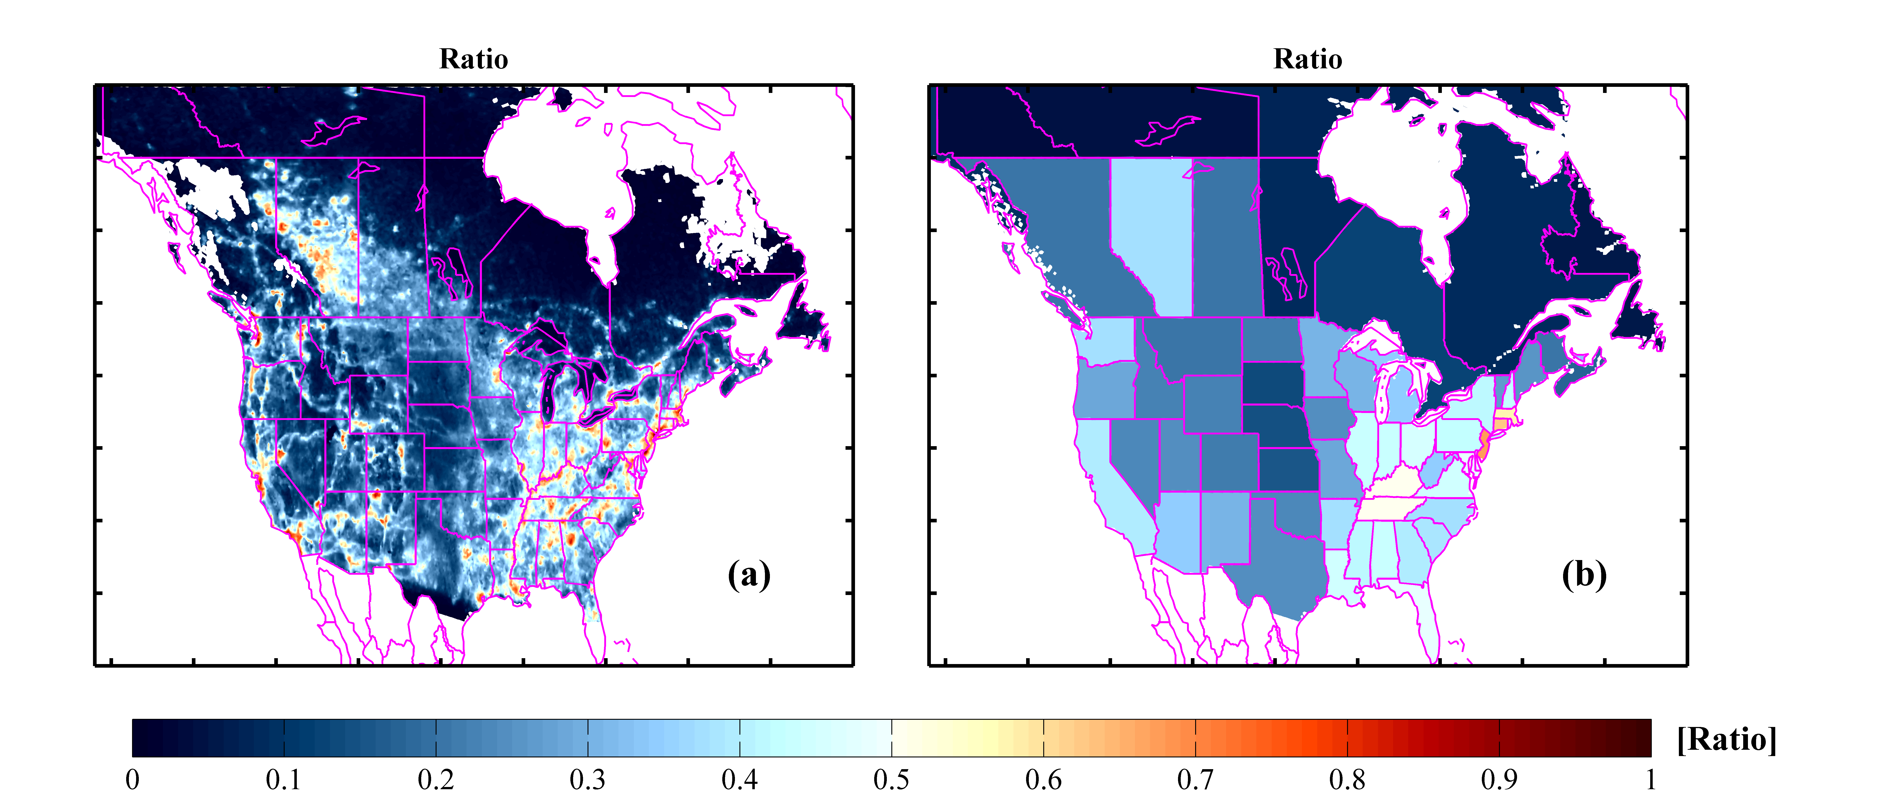

Figure 2. Ratio of nitrogen dioxide (NO2) and Total Nr (NH3+NO2) dry deposition flux over North America. The yellow-to- red (values >0.5) areas indicated where the dry deposition of Nr (NH3+NO2) has a greater contribution from NO2, whereas the blue (values <0.5) regions indicate dominance from NH3 dry deposition.



Figure 3. Warm season (April-September, 2013) MODIS Fire Count (a), CrIS NH3 total dry deposition flux (b), CrIS NH3 background dry deposition flux (c), and Flux Ratio (d) over northern region in Canada.

# Supplementary Material

## Data Processing Methods

We only used satellite observations that had at least 0.1 degrees-of-freedom for signal (DOFS) to ensure that only observations with information coming from the observations (not just apriori information) were used, and filtered the data for thick clouds by only using retrievals that have an ammonia signal in the satellite spectra. Monthly median ground-level satellite NH3 observations were used to fill the gaps where satellite observations are not available (i.e. under thick clouds).

Here, we exclude the cross-track pixels affected by the row anomaly (http://www.knmi.nl/omi/research/product/rowanomaly-background.php. We use OMI NO2 observations with cloud radiance fraction <0.3, and solar zenith angles <78o following Kharol et al. [2015]. The OMI values averaged over an 18-km averaging-radius that is oversampled onto a ~15x15 km2) grid. The approach described by Lamsal et al. [2008] is used to estimate the ground-level NO2 mixing ratio over North America for the warm season of 2013. The ground-level NO2 mixing ratio $S$ is estimated from the local OMI tropospheric NO2 column $Ω$ as:

$S_{OMI}=Ω_{OMI }× \frac{S_{model}}{Ω_{model}}$ (1)

The subscript $model$ represents GEM-MACH model. More details on the procedure are discussed in McLinden et al. [2014].

Nr deposition flux for each month and then average to provide the warm season (6-month) mean values reported.

## Figures

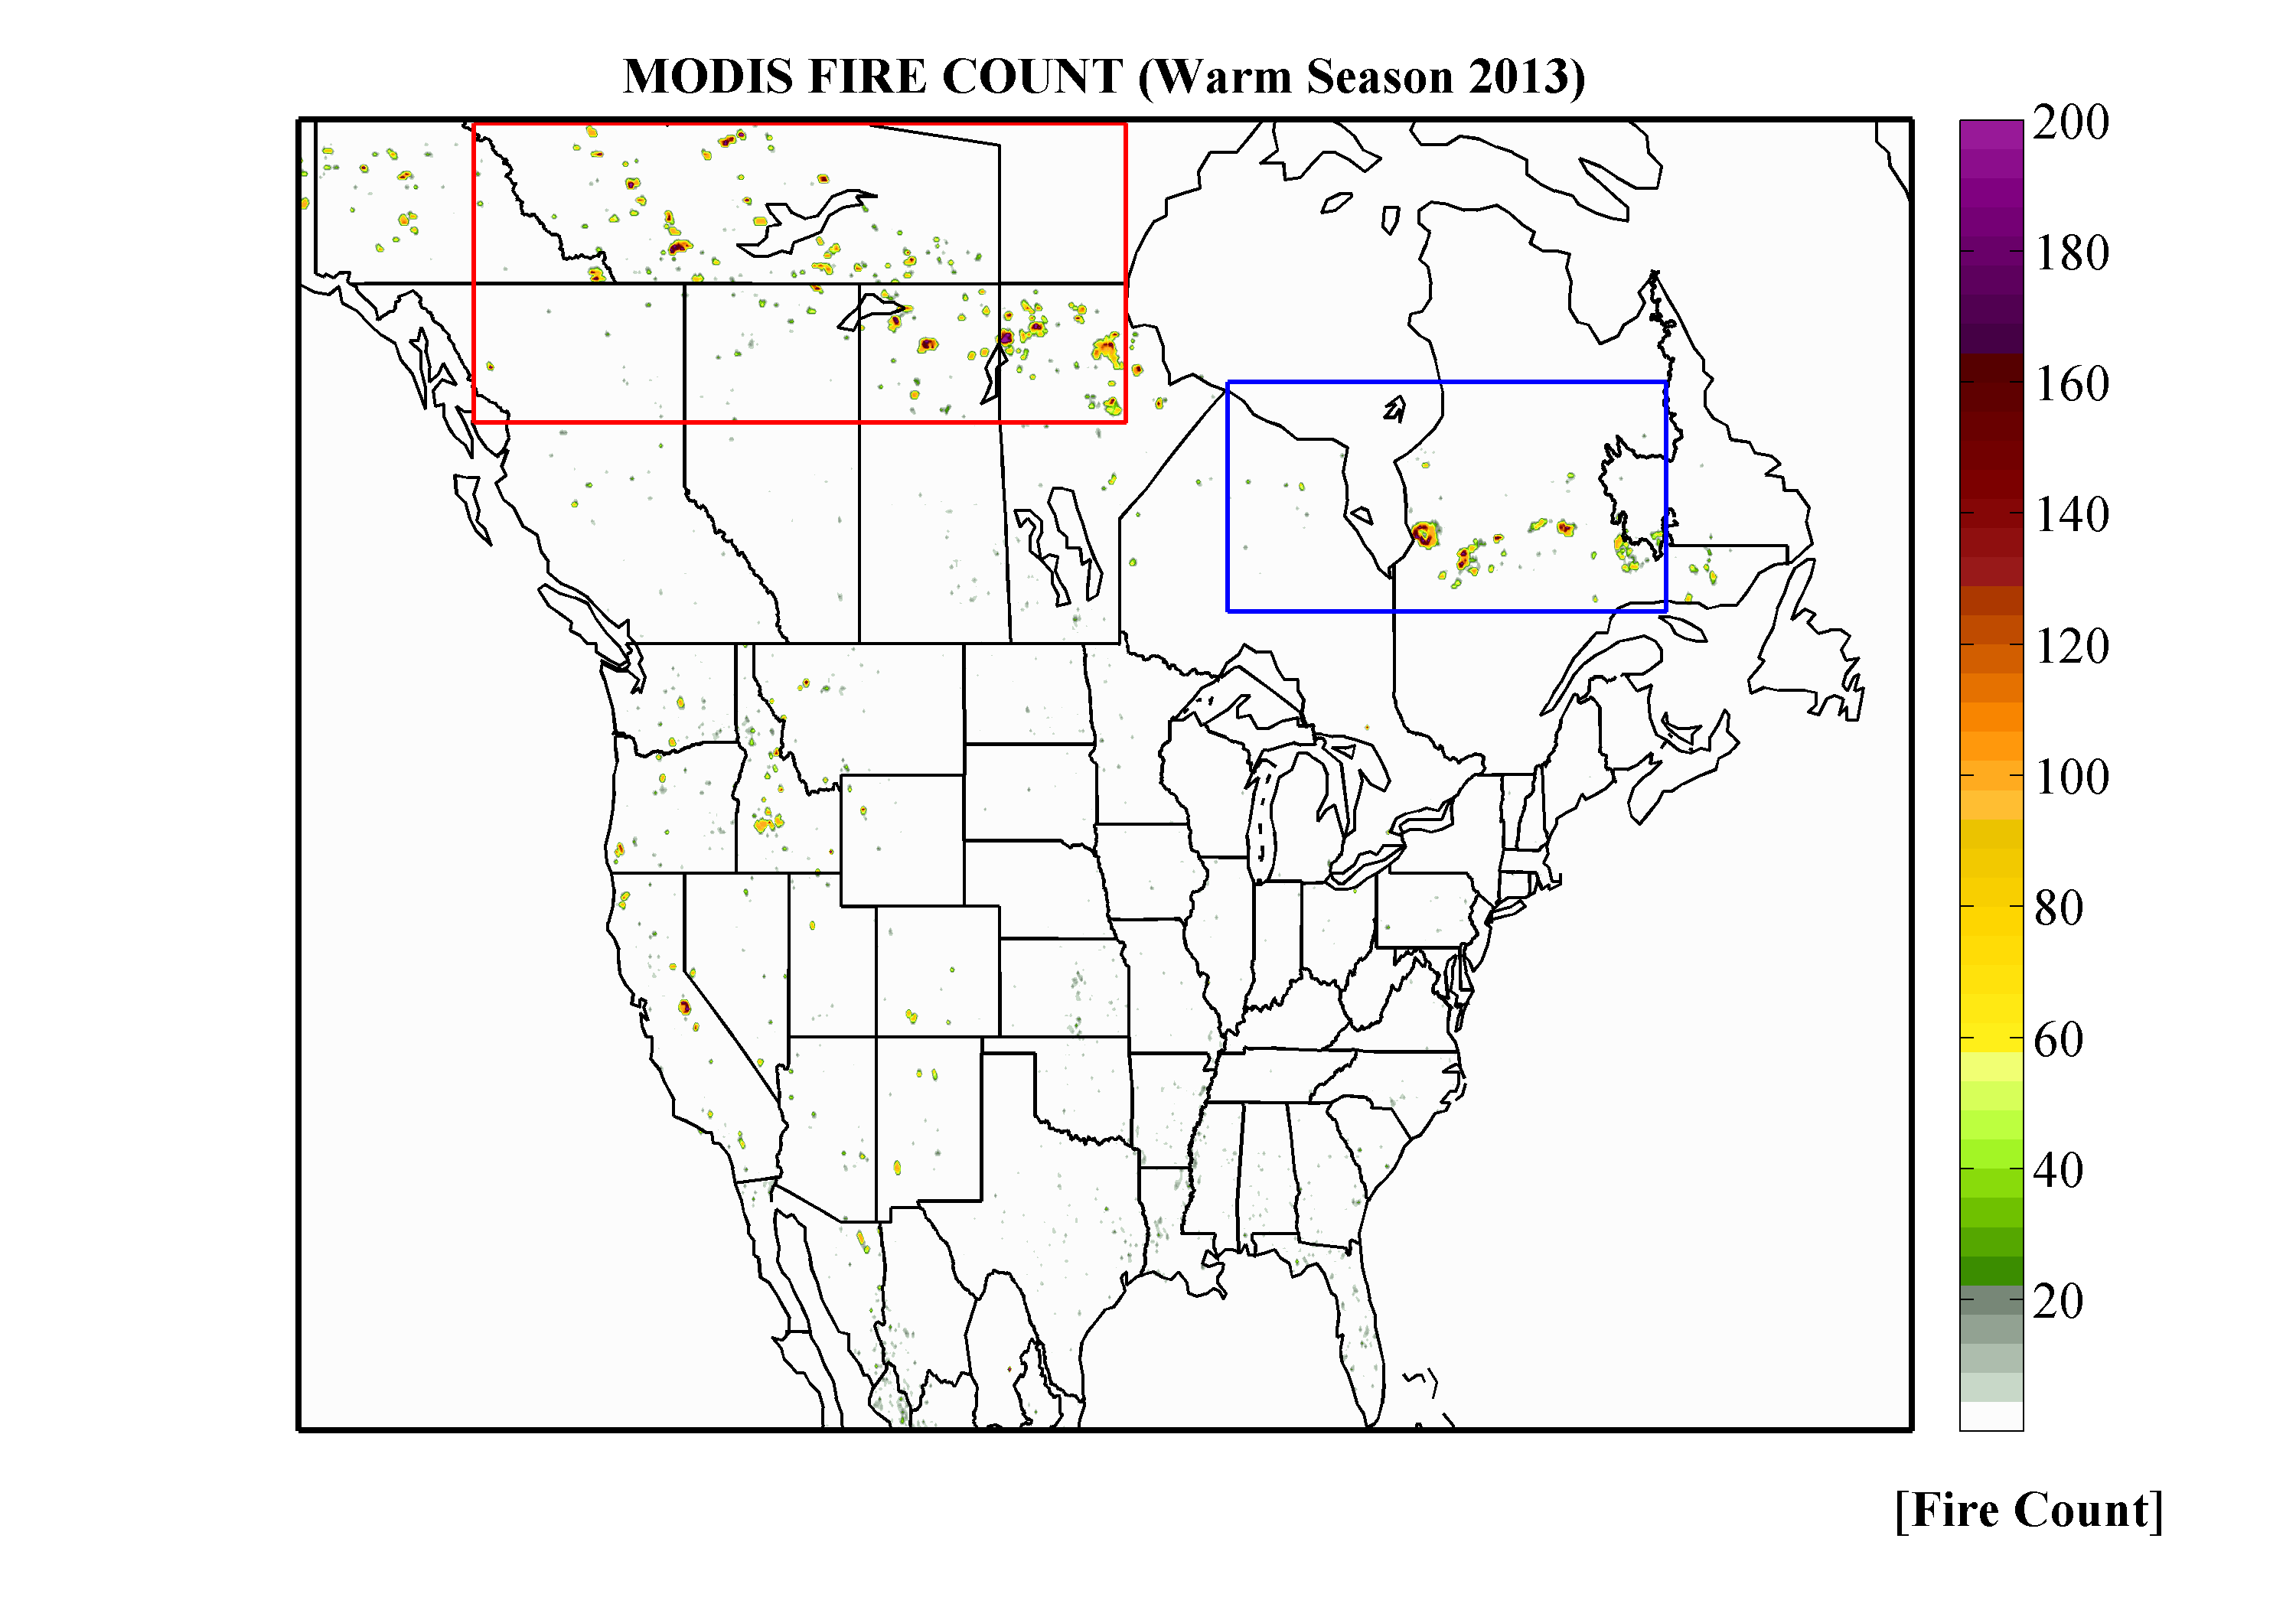

Figure 4. MODIS Terra total fire counts per 0.1 x 0.1 degree (~10 x 10 km2) bins over North America during the warm season. The two rectangles are the regions look at in detail in Figure 3.

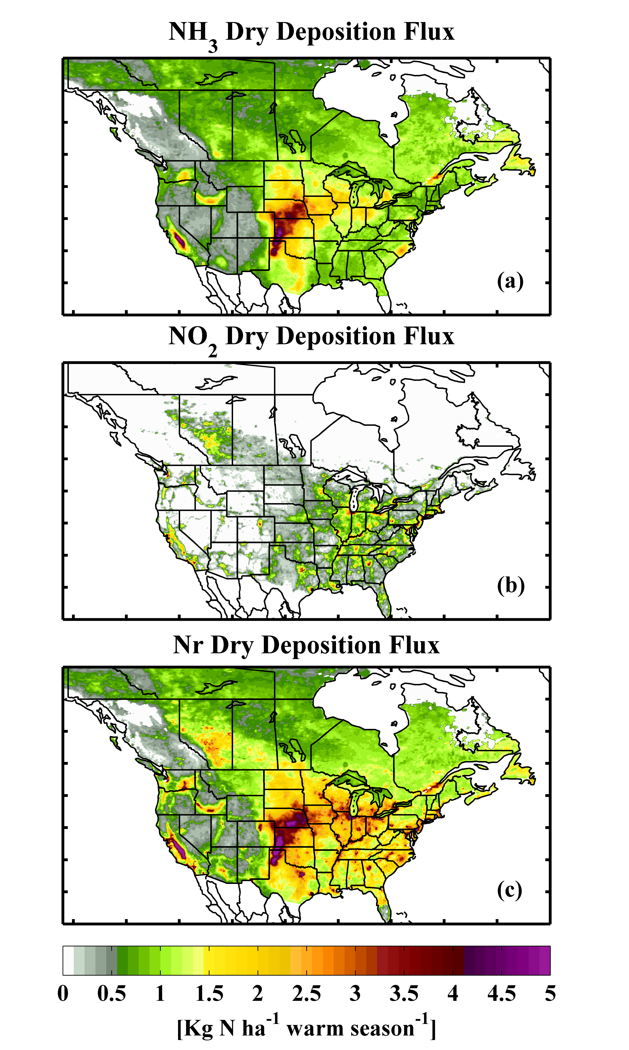

Figure .



Figure



Figure .



Figure .